Technical Design Documetation

WMS Exception Handler Framework

Version 1.0

Revision History

Date | Rev. | Description | Author | Section(s) Changed
06-07-13 | 1.0 | First draft | Edward Suryadi | All

WMS Exception Handler Framework

Table of Contents

1. Introduction 1
1.1 Overview 1
1.2 Purpose 1
1.3 Scope 1
2. Design 2
2.1 Exception Handler Components 2
2.1.1 WMSException Class 2
2.1.2 WMSExceptionHandlerInterceptor Class 2
2.1.3 WMSExceptionHandler interface 2
2.1.4 WMSError Constants 3
2.1.5 ErrorUtil Class 3
2.1.6 ExceptionService Interface 3
2.1.7 ExceptionDao Interface 3
2.1.8 Error Class 3

Introduction

Overview

The WMS exception handler framework is an add-on module that will catch any exceptions that are thrown within the application code and then handle them in one central place which is the Exception Handler class.

Purpose

The purpose of the exception handling framework is to:
- Catch every possible exception that’s thrown anywhere in the application code without manually implementing the try-catch exception block each time the class method is called. This allows developers to focus on their code logic without regard to exceptions that would crash the application if they forget to catch the exceptions.
- Free the application code from the try-catch exception block and copy and paste exception handling code that will make the application code cleaner, allowing developers to focus on the code logic without regard to exception handling.
- Avoid unexpected system crashes since unhandle exceptions, e.g., the Java null pointer exception and runtime exception, are being implemented. Instead, end-users will see user friendly error messages and will still be able to move forward and use other application functionality.
- Centralize the exception handling code, including:
  - Logging to error log files
  - Returning error messages back to end users
  - Sending e-mail notification messages
  - Performing transaction roll backs, etc.
- Each of these above-referenced functions can be performed at one point in the exception handler object instead of everywhere in the application code.
- Manage the common, service, and application error codes and error messages at one point and externalize/internationalize the error message instead of manually embedding the message in the exception classes’ constructor/method or anywhere in the code.
- Manage, organize, and catalog the error codes, error messages, and exception classes to better recognize or detect the cause of faulty code or system failure(s) at given points in time.

Scope

WMS Exception Handler framework can be used on any application (web or stand-alone) that uses Spring Framework.

Design

Exception Handler Components

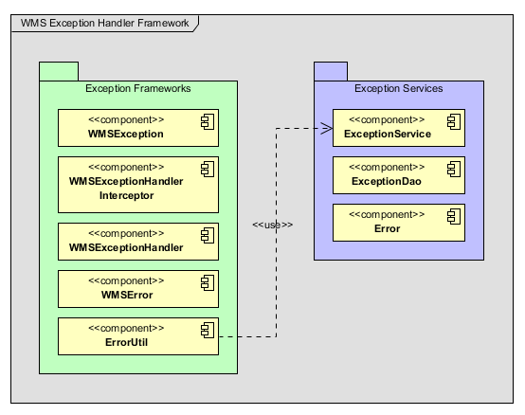

WMSException Class
The WMSException Class is the root exception of WMS Application that allows the exception handler to handle this type of exception for a special handling. All exception that needs special handling needs to extend this exception.

WMSExceptionHandlerInterceptor Class
The WMSExceptionHandlerInterceptor class is the Exception Interceptor class that executes the ExceptionHandler object to process the exception handling task. WMSExceptionHandler gets the ExceptionHandler object from the ExceptionHandler spring context configuration class where all the ExceptionHandler beans are registered. Spring Aspect will intercept the exception and execute this class.

WMSExceptionHandler interface
The WMExceptionHandler interface contains the exception handling method that must be implemented by the ExceptionHandler class.

WMSError Constants
The WMSError class is a constant class that contains list of generic errors that is used when throwing the WMSException.

ErrorUtil Class
The ErrorUtil class is a utility class to get error meta-data information from the error table in database.

ExceptionService Interface
The ExceptionService interface is a service interface to perform database transaction which includes but not limited saving, update, delete and retrieve error code from the database table for the exception handler framework. .

ExceptionDao Interface
The ExceptionDao interface an exception DAO (Data Access Object) interface to perform CRUD database operation. The ExceptionDAO interface is a generic interface that can be used to access to any database table, not only the Error table.

Error Class
The Error class is a database domain object class that represents the error table.

